UNLOCKING INSIGHTS INTO THE GLOBAL AIR TRANSPOTATION WITH TABLEAU

1. INTRODUCTION
   1. OVERVIEW

THE GLOBAL AIR TRANSPORTATION NETWORK DATASET IS A COMPREHENSIVE COLLECTIN OF INFORMATION ON AIRPORTS, AIRLINES AND THEIR ROUTES . IT CONTAINS THE INFORMATION SUCH AS NAMES, CITIES, COUNTRIES ,CODES (IATA AND ICAO)LONGITUDES ,LATITUDES OF AIRPORTS ACROSS THE WORLD WITH DETAILED TIMEZONE AND DAYLIGHT SAVING TIME DATA.

* 1. PURPOSE

THE PURPOSE OF THIS PROJECT IS TO SPECIFY THE GLOBAL AIR TRANSPORTATION EASILY WITH TABLEAU . THE DATA ABOUT THESE ABOVE MENTIONED INFORMATION CAN BE FOUND EASILY.

1.DATA ANALYSIS AND VISUALISATION

2.ROUTE OPTIMIZATION

3.OPERATIONAL EFFICIENCY

4. ENVIRONMENTAL IMPACT

5.FINANCIAL ANALYSIS

2.PROBLEM STATEMENT AND DESIGN THINKING

2.1 EMPATHY MAP

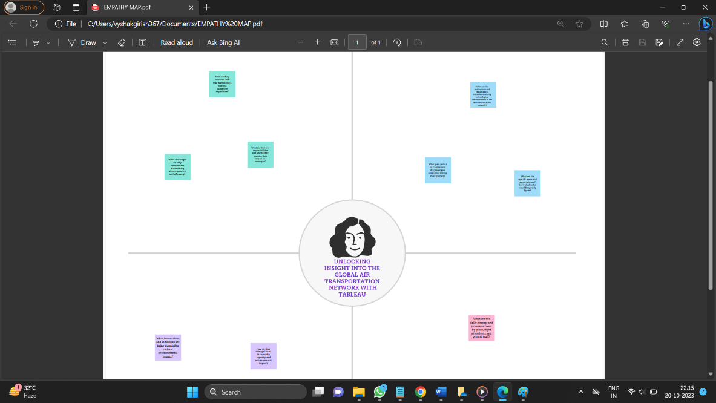

2.2 IDEATION OF BRAIN STROMING MAP

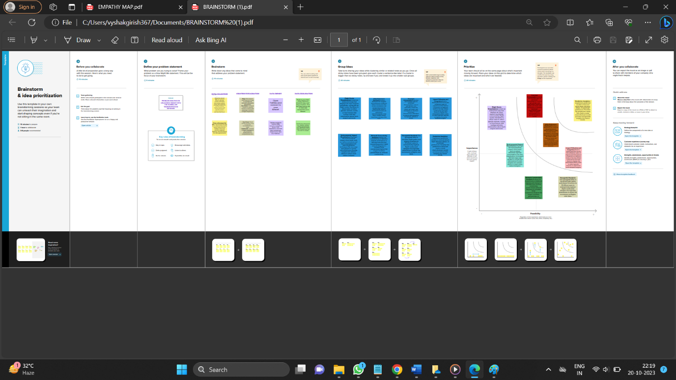

3 RESULT

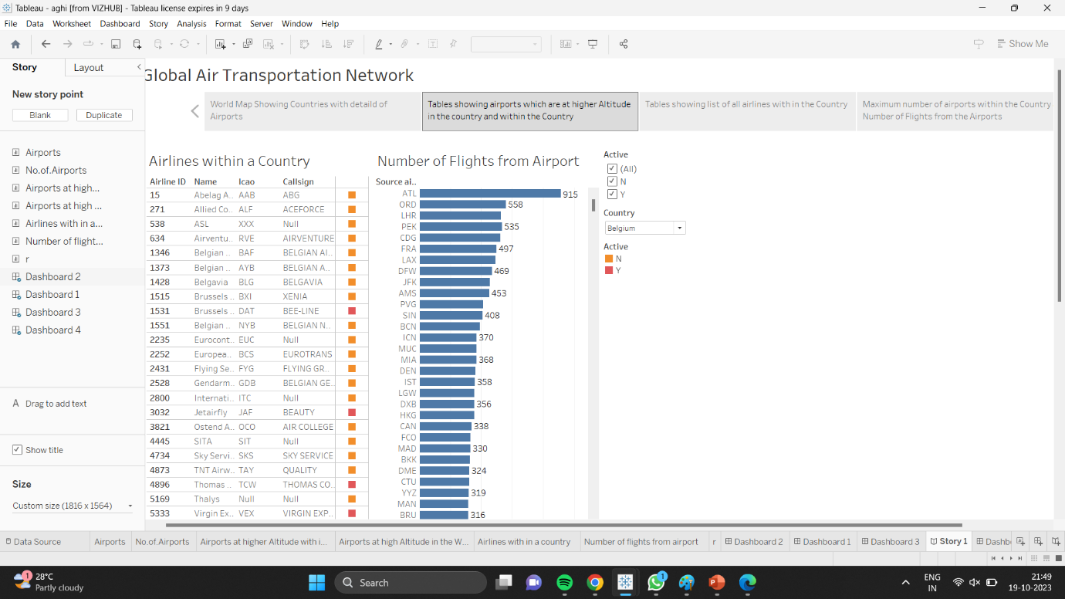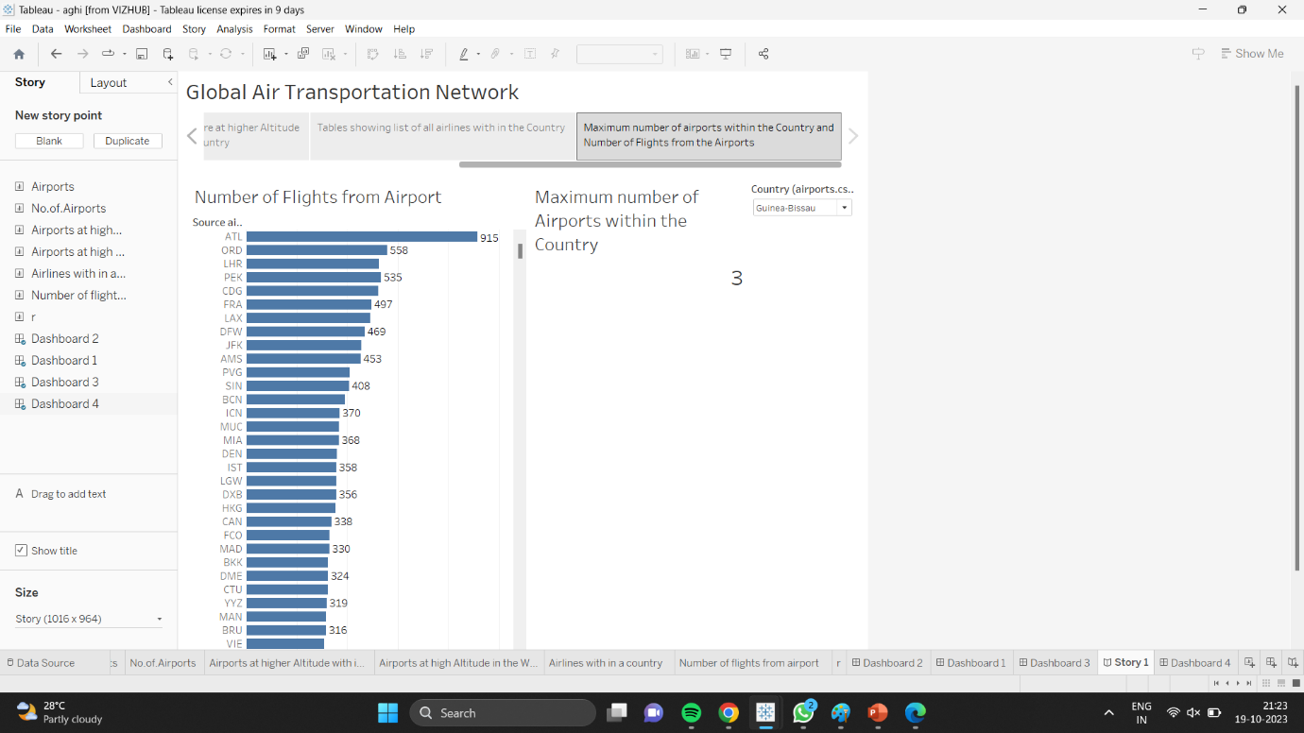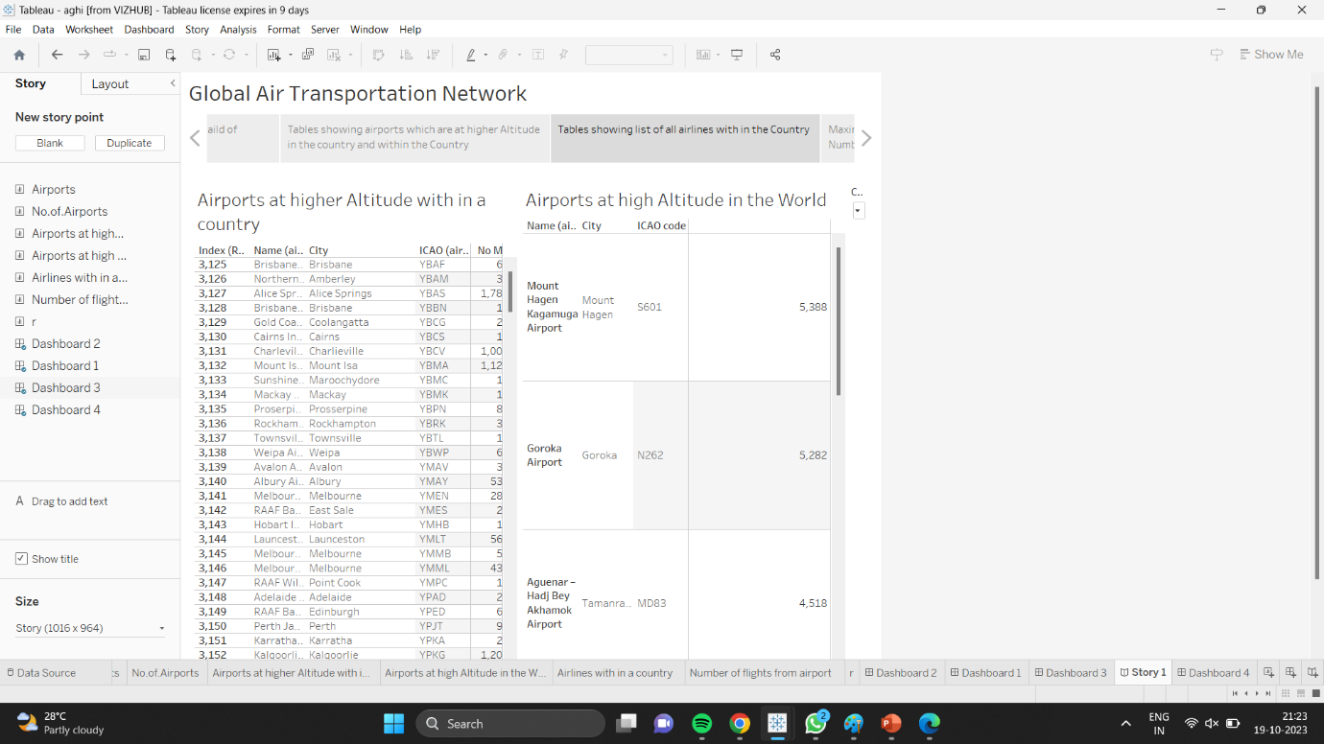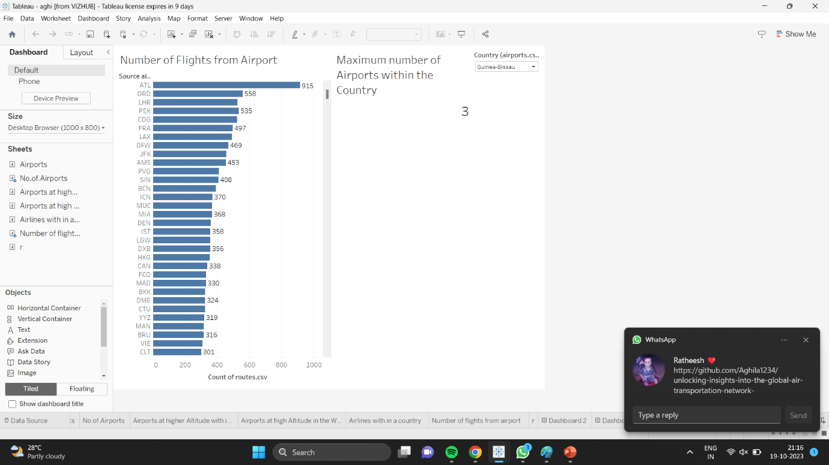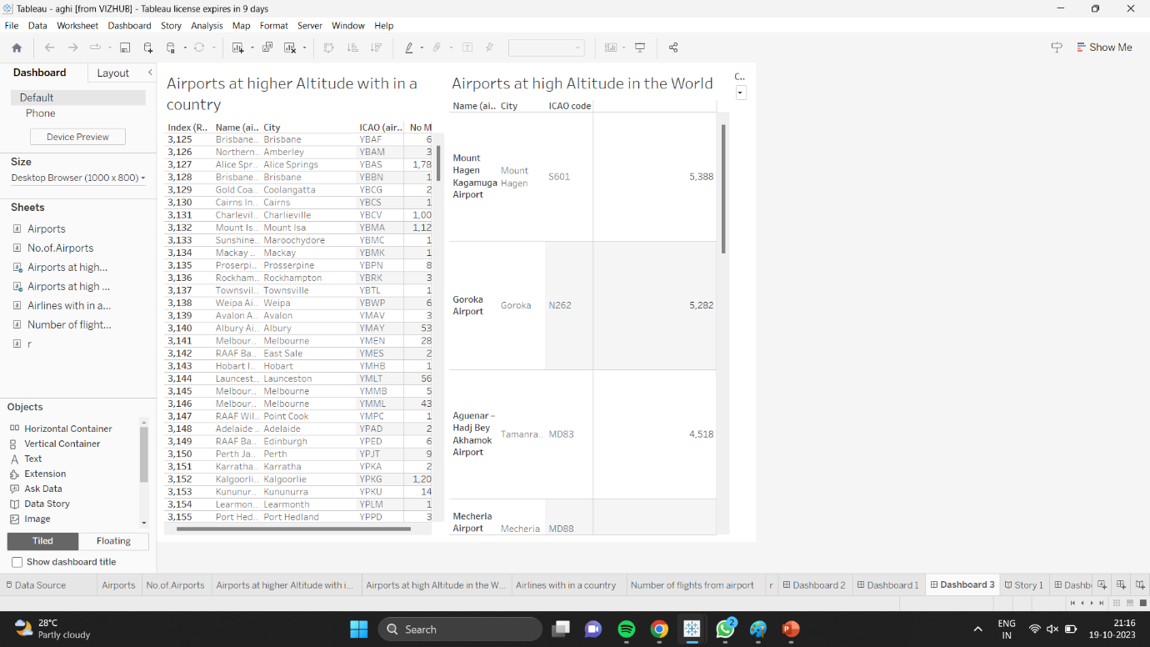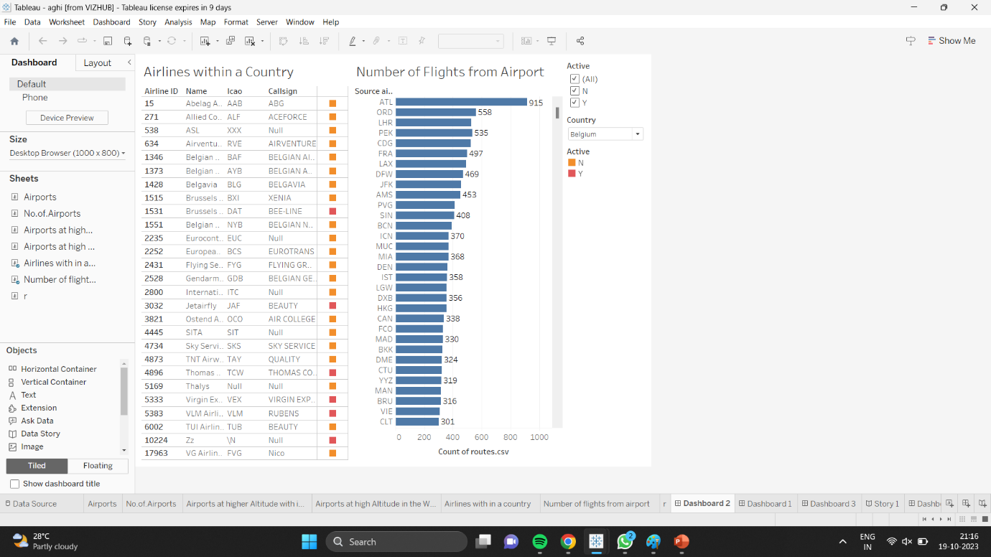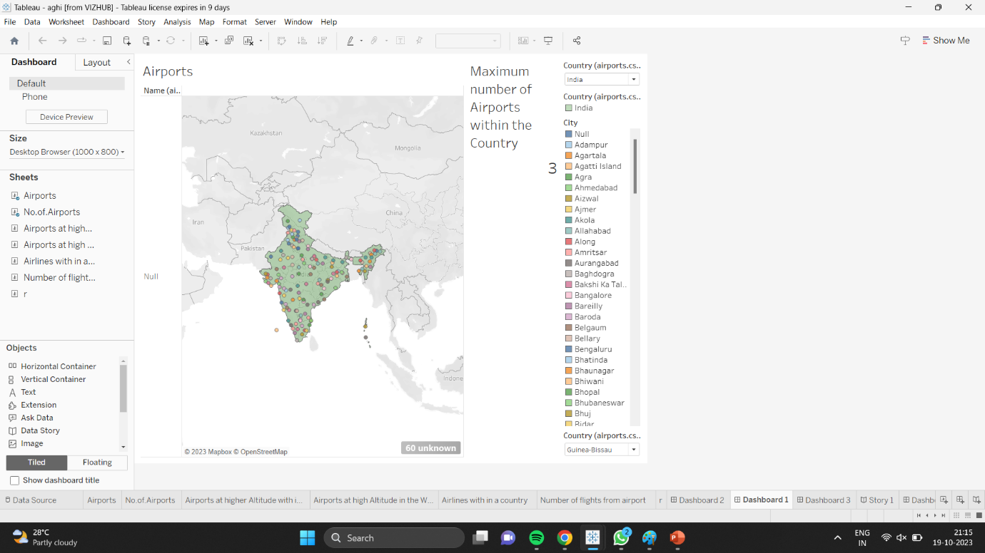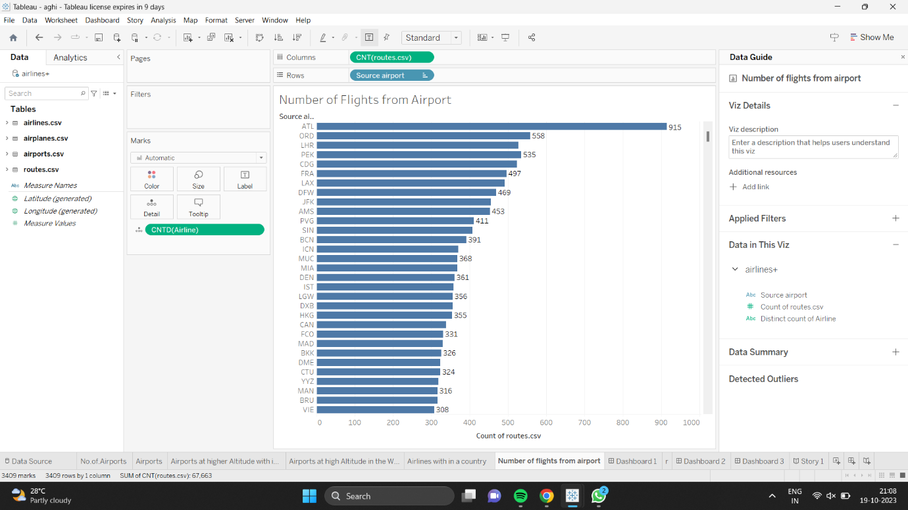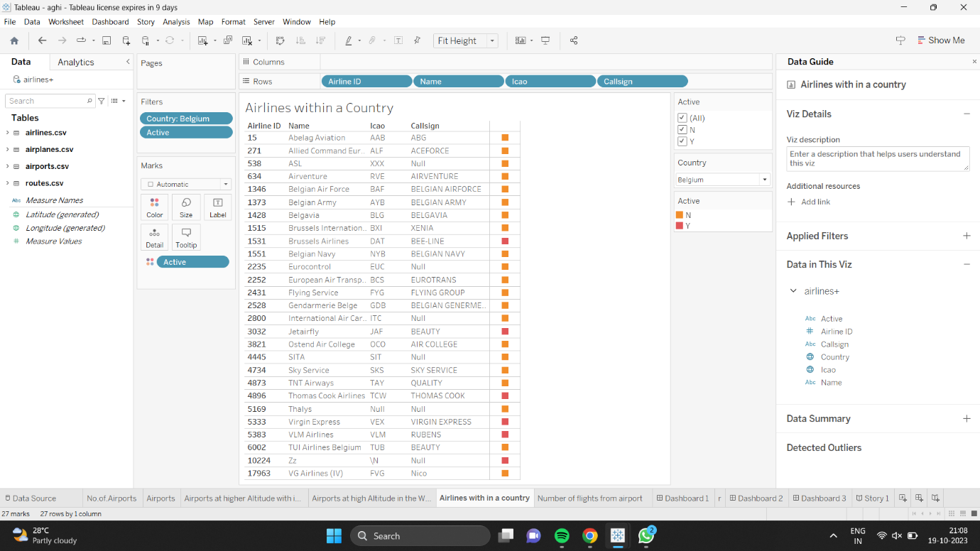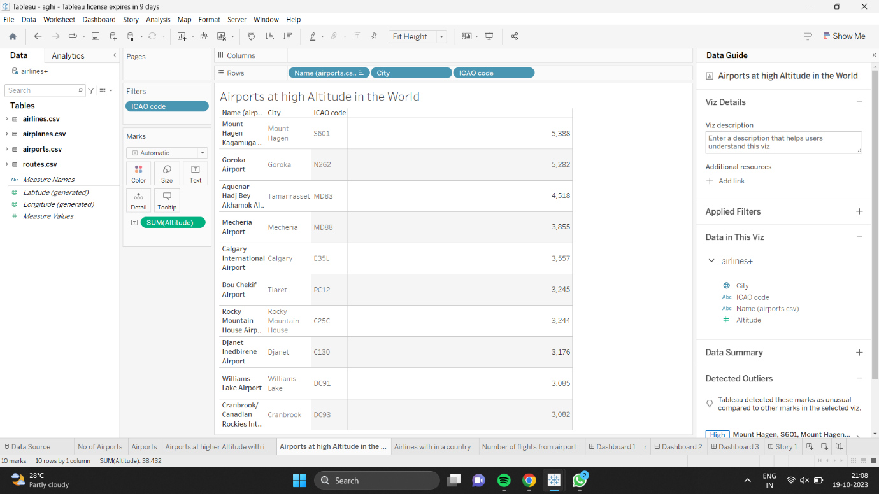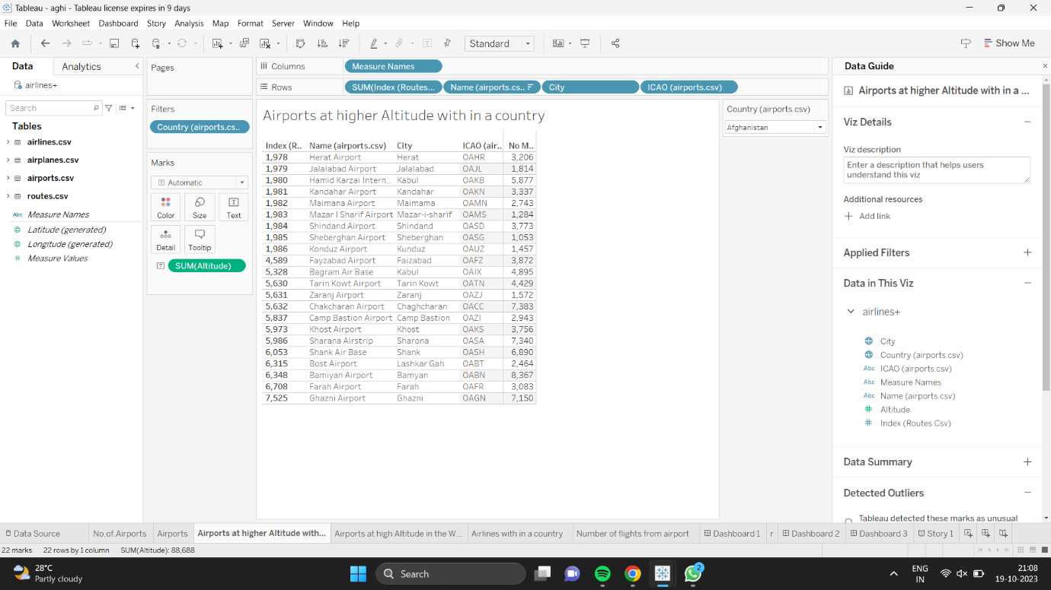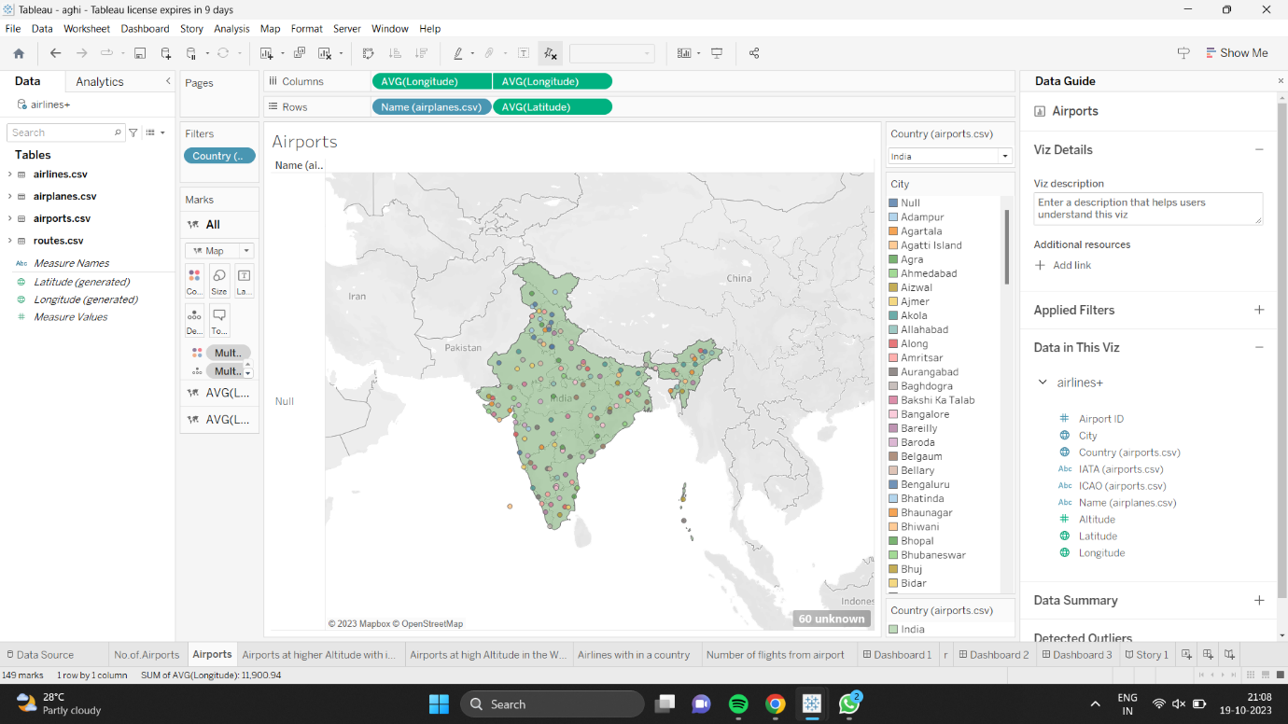

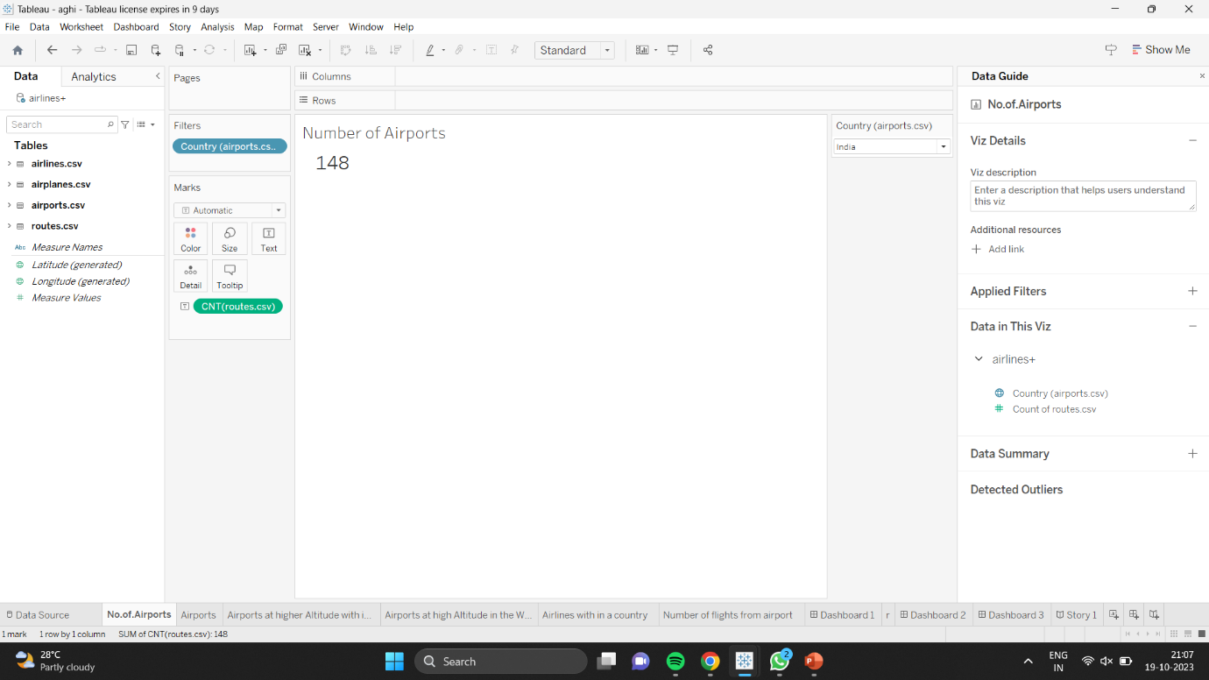

4. ADVANTAGES AND DISADVANTAGES

ADVANTAGES

1. DATA VISUALIZATION
2. REAL TIME ANALYSIS
3. GEOSPATICIAL ANALYIS
4. DATA INTEGRATION
5. CUSTOMIZATION

DISADVANTAGES

1. COST
2. STEEP LEARNING CURVE
3. DATA SIZE LIMITATION
4. MAINTEANCE AND UPDATE
5. DEPENDENCY ON DATA QUALITY
6. LIMITED COLLABRATION

5. APPLICATIONS

1. ROOT OPTIMIZATION
2. PASSENGER ANALYTICS
3. DELAY ANALYSIS
4. AIRPORT PERFORMANCE
5. MARKET RESEARCH
6. SAFETY AND COMPLAIANCE
7. CRISES MANAGEMENT
8. ENVIRONMENTAL IMPACT
9. CARGO AND FREIGHT MANAGEMENT
10. CUSTOMER EXPERIENCE AND ENHANCEMENT
11. CONCLUSION

FROM THIS WE CAN CONCLUDE THAT USING TABLEAU FOR UNLOCKING INSIGHTS INTO THE GLOBAL AIR TRANSPORTATIN NETWORK CAN BE POWERFUL , BUT IT COMES WITH COST COMPLEXITY ,AND SCZLABILITY CONSIDERATIONS THAT NEED TO BE WEIGHED AGAINST THE POTENTIAL BENEFITS.